**The Top 10 Most Used High Level Programming Languages World Wide**

**According to the most recognizable studies and indexes, the following table shows the ranking of the most important high level programming languages recently:**

|  |  |  |  |  |  |  |  |  |  |  |  |
| --- | --- | --- | --- | --- | --- | --- | --- | --- | --- | --- | --- |
| **#** | **Language** | **Tiobe Index** | | **in-Demand** | | **Pull Requests** | | **IEEE Index** | | **Totals** | **Ave.** |
| **1** | **Java** | 13.27% | 22.48% | 26,269 | 21.77% | 986,000 | 12.33% | 100 | 11.44% | **68.01%** | **17.00%** |
| **2** | **Java Script** | 2.47% | 4.18% | 24,248 | 20.09% | 2,300,000 | 28.76% | 84.3 | 9.64% | **62.67%** | **15.67%** |
| **3** | **Python** | 3.78% | 6.40% | 11,757 | 9.74% | 1,000,000 | 12.50% | 93.4 | 10.68% | **39.33%** | **9.83%** |
| **4** | **C** | 10.16% | 17.21% | 8,111 | 6.72% | 239,000 | 2.99% | 99.2 | 11.34% | **38.26%** | **9.57%** |
| **5** | **C++** | 4.72% | 7.99% | 8,584 | 7.11% | 413,000 | 5.16% | 95.5 | 10.92% | **31.19%** | **7.80%** |
| **6** | **C#** | 2.82% | 4.78% | 13,523 | 11.20% | 326,000 | 4.08% | 92.2 | 10.54% | **30.60%** | **7.65%** |
| **7** | **Ruby** | 1.42% | 2.41% | 4,417 | 3.66% | 870,000 | 10.88% | 78.6 | 8.99% | **25.93%** | **6.48%** |
| **8** | **PHP** | 1.59% | 2.69% | 4,971 | 4.12% | 559,000 | 6.99% | 84.6 | 9.68% | **23.48%** | **5.87%** |
| **9** | **R** | 1.91% | 3.24% | 1,599 | 1.32% |  |  | 74 | 8.46% | **13.02%** | **3.26%** |
| **10** | **MATLAB** | 1.57% | 2.66% | 789 | 0.65% |  |  | 72.6 | 8.30% | **11.62%** | **2.90%** |
| **11** | **Go** | 1.39% | 2.35% | 4,038 | 3.35% | 285,000 | 3.56% |  |  | **9.26%** | **2.32%** |
| **12** | **Swift** | 1.57% | 2.66% | 1,510 | 1.25% | 107,000 | 1.34% |  |  | **5.25%** | **1.31%** |
| **13** | **Perl** | 1.44% | 2.44% | 3,243 | 2.69% |  |  |  |  | **5.13%** | **1.28%** |
| **14** | **Objective-C** | 1.50% | 2.54% | 1,730 | 1.43% | 66,000 | 0.83% |  |  | **4.80%** | **1.20%** |
| **15** | **CSS** |  |  |  |  | 335,000 | 4.19% |  |  | **4.19%** | **1.05%** |
| **16** | **VB.NET** | 2.47% | 4.18% |  |  |  |  |  |  | **4.18%** | **1.05%** |
| **17** | **Scratch** | 1.37% | 2.32% | 700 | 0.58% |  |  |  |  | **2.90%** | **0.73%** |
| **18** | **Scala** |  |  | 1,827 | 1.51% | 99,000 | 1.24% |  |  | **2.75%** | **0.69%** |
| **19** | **Typescript** |  |  |  |  | 207,000 | 2.59% |  |  | **2.59%** | **0.65%** |
| **20** | **Shell** |  |  |  |  | 206,000 | 2.58% |  |  | **2.58%** | **0.64%** |
| **21** | **Assembly** | 1.47% | 2.49% |  |  |  |  |  |  | **2.49%** | **0.62%** |
| **22** | **Delphi** | 1.40% | 2.37% |  |  |  |  |  |  | **2.37%** | **0.59%** |
| **23** | **SQL** | 1.37% | 2.32% |  |  |  |  |  |  | **2.32%** | **0.58%** |
| **24** | **Visual Basic** | 1.35% | 2.29% |  |  |  |  |  |  | **2.29%** | **0.57%** |
| **25** | **Apex** |  |  | 1,609 | 1.33% |  |  |  |  | **1.33%** | **0.33%** |
| **26** | **SAS** |  |  | 975 | 0.81% |  |  |  |  | **0.81%** | **0.20%** |
| **27** | **Crystal** |  |  | 789 | 0.65% |  |  |  |  | **0.65%** | **0.16%** |

**But if we want to have a very long term historical view, then the following table shows the positions of the top 10 programing languages of many years back. Please note that these are average positions for a period of 12 months:**

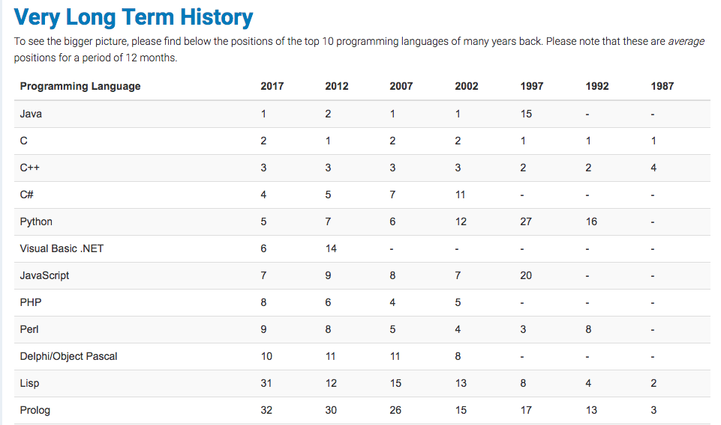

**So, we can come to a fast conclusion about the top 10 programming languages as below:**

1. **Java.**
2. **Java Script.**
3. **Python.**
4. **C.**
5. **C++.**
6. **C#.**
7. **Ruby**
8. **PHP.**
9. **R.**
10. **MATLAB.**

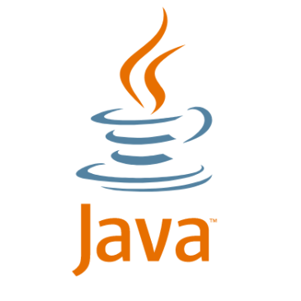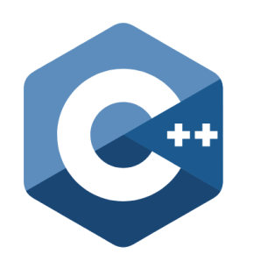

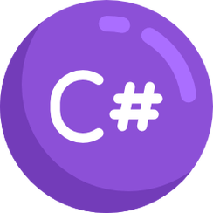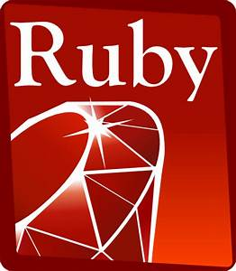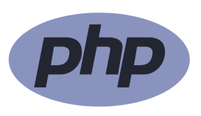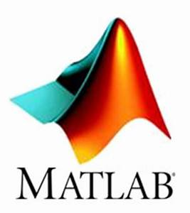

**Features Comparison**

|  |  |  |
| --- | --- | --- |
| **#** | **Language** | **Features** |
| 1 | Java | Simple, Object-Oriented, Portable, Platform independent, Secured, Robust, Architecture neutral, Interpreted, High Performance, Multithreaded, Distributed, Dynamic |
| 2 | Java Script | Light Weighted, Scripting Language, Interpreter Based, Event Handling, Case Sensitive, Control Statement, In-Built Function, Looping Statement, If Else Statement, Client Side Technology, Validating User’s Input, Object-based Scripting |
| 3 | Python | Easy, Expressive, Free and Open Source, High-Level, Portable, Object Oriented, Extensible, Embeddable, Interpreted, Large Standard Library, GUI Programming, Dynamically Typed |
| 4 | C | Fast, Efficient, Portability, Function rich Libraries, Modularity, Easy to Extend, Variety of Datatypes, Power Operators, Low Level Support, Bit Manipulation, High Level Features, Syntax Based, Case Sensitive, Structure Oriented, Use of Pointer, Platform Dependent, Compiler Based, Simple |
| 5 | C++ | Simple, Syntax Based, Case Sensitive, Platform Dependent, Object Oriented, Portability, Powerful, Fast, Efficient, Modularity, Compiler Based, Uses of Pointer, Huge Function Library, Structured, Memory Management, Extensible, Recursion, Compiler Based |
| 6 | C# | Fast Speed, Simple, Modern, Object Oriented, Type Safe, Interoperability, Scalable, Updateable, Component Oriented, Structured, Rich Library, Error Handling, Automatic Component, Automatic Garbage Handling, Organized Class Library, Neat Features, Supercharged IDE, |
| 7 | Ruby | Object-oriented, Flexibility, Expressive feature, Mixins, Visual appearance, Dynamic typing and Duck typing, Exception handling, Garbage collector, Portable, Keywords, Statement delimiters, Variable constants, Naming conventions, Keyword arguments, Method names, Singleton methods, Missing method, Case Sensitive, Open Source, General Purpose, Interpreted, Server-side Scripting, Easy Syntax, Embedded into HTML, Scalable, Easy Maintainable |
| 8 | PHP | Simple, Easy, Error Reporting, Interpreted, Efficiency, Familiarity, Open Source, Case Sensitive, Flexibility, More Faster, Platform Independent, Real-Time Access Monitoring, Simplicity, Security |
| 9 | R | Supports Matrix Arithmetic, Interpreted, Object Oriented, Generic Functions, Procedural Programming with Functions, Packages, Database Input, Data Handling |
| 10 | MATLAB | Dealing with Matrices and Arrays, 2-D and 3-D Plotting and graphics, Linear Algebra, Algebraic Equations, Non-linear Functions, Statistics, Data Analysis, Calculus and Differential Equations, Numerical Calculations, Integration, Transforms, Curve Fitting, Various other special functions |